**Displacement Type Damper**

**Feature**

可有效降低位移反應，不受環境影響較為穩定

週期降低提升地震力輸入

**Flexural type ( bending - TADAS, ADAS, Rectangular plate )**

抗彎構架側向勁度, 高度寬厚比, ${SHR}_{a}, SHR_{d}$

**Shear type ( SLEA )**

energy dissipate through in-plane shear deformation that cause yielding

**Axial type ( UB, BIB, BRB )**

抗彎構架側向勁度

**Friction type ( friction dampers )**

Add stiffness, after yielding add damping.

Disp. and vel. will reduce but accel. may not.

**Velocity Type Damper**

**Feature**

隨時啟動, 環境敏感

**VE: 剪力變形消能，會提供勁度所以會像位移型一樣提升地震力**

結構頻率, 環境溫度, 剪應變, 材料溫度

**VD: 阻尼動能轉換熱能，沒有勁度較利於控制加速度**

結構頻率, 阻尼冪次, 阻尼元件阻尼比

**系統識別**

數值: 拉放試驗, 白雜訊輸入, 隨機遞減法: $ξ=\frac{1}{2πj}ln⁡(\frac{u_{i}}{u_{i+j} })$

現地: 激震器, 半功法: $ξ=\frac{{(f}_{2}-f_{1})}{(f_{2}+f_{1})}$

**VE**

**Feature**

小變形時, 比起震幅大小. 環境溫度跟振動頻率對VE damper有更大的影響

環境溫度或剪應變的上升會減低VE damper的勁度.

隨著震動的次數跟幅度增加, 會提高VE damper的溫度而減低VE damper的勁度, 但這影響會隨著震動的次數增加而下降.

Dissipate energy though heat.

Additional damping provide as soon as structure vibrate.

**Material Property**



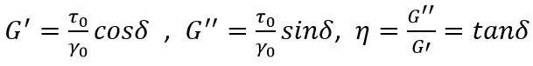

**公式**

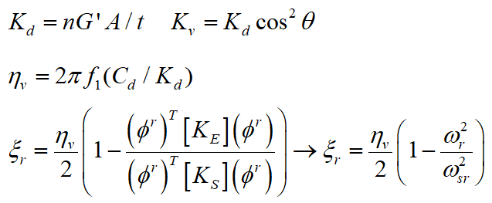 $K_{d}=\frac{2ξ}{η-2ξ}K_{s}$

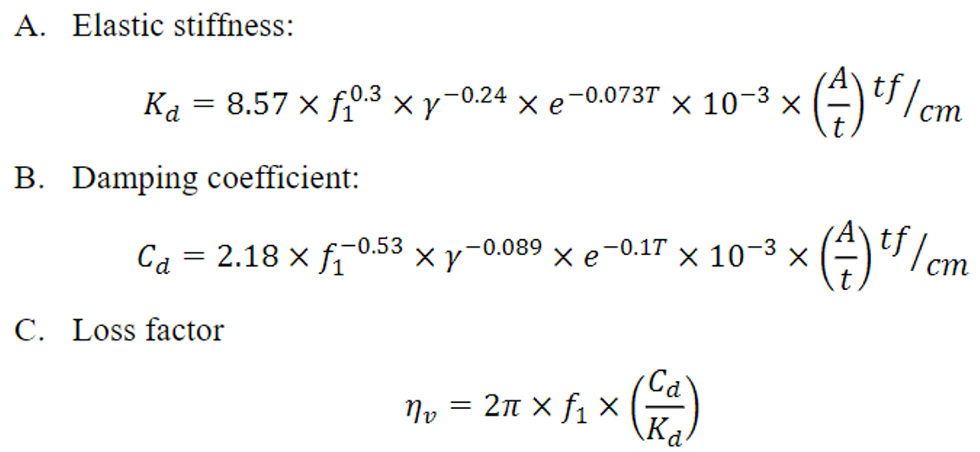

**設計流程**

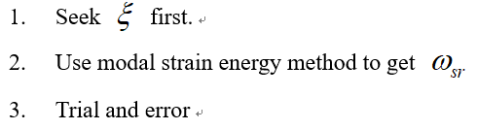

Determine the design damping ratio

Design primary frame: Vº

Determine damper location

Design dampers

Estimate damping ratio with designed dampers

Dynamic analysis of the designed viscoelastically damped structure, check code requirements

**VD**

**Feature**

和速度同向, 位移反向(差90度)

在特定頻率(f<4Hz)內沒有儲存勁度

Not very significant affected by temperature.

速度較小時,非線性阻尼器可以提供較大之阻尼力. 但速度較大時增加的力量就有限.一般用非線性阻尼器較經濟.

不具有儲存勁度,不影響結構週期,設計起來較為方便

**公式**

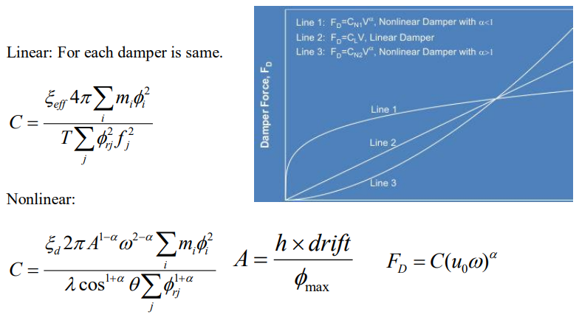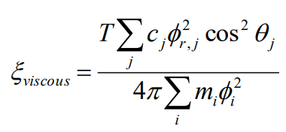

**設計流程**

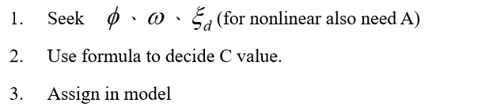

**Seismic Isolation**

**Basic Requirements**

足以承受垂直向載重(勁度及強度)

在大地震下,有足夠的柔度可以延長結構物側向勁度

可以承受額外阻尼來降低位移需求

隔震層要有一定的勁度以抵抗風力

隔震層要有能力復位

可以提供第二防禦措施

**Feature**

The effect of substructure is really important in particular when substructure possesses a smaller stiffness and a larger mass.

The design of substructure and superstructure with higher vibration frequencies exhibits a better seismic performance.

The participation of the modal responses of the higher modes should be taken into account for the design of substructure.

The responses at isolation layer and superstructure are significantly enlarged within the certain frequency ratio bandwidth due to the modal coupling effect.

Nonlinear response history analyses are needed for mid-story isolation designs.

**Type**

NRB

鋼板用於提供垂直勁度，天然橡膠用於提供水平柔向勁度。

easy and economical to make.

low damping, need to provide extra damping.

LRB

鉛心提供剪力降伏幫助NRB消能。

HDRB

加入石化業摻料，提高消能能力，在微震下也具有良好的消能效果。

FPS

combines sliding and re-centering mechanism, composes of an articulated slider on a stainless steel ball surface. The contact between the slider and ball surface is coated with low friction, low wear and auto lubricates composite material.

隔震週期與重量無關。側向勁度正比於重量，質心與勁度中心重合 (無偏心)

Roller-Type Bearing(RTB)

以滾動行為產生上下結構相對運動，隔離地震輸入能量，可傳遞最大地震力為上部結構重量因支承斜面造的重力回復力與滾動摩擦力，相較於滑動摩擦，滾動摩擦具有較低的起始摩擦力。

**公式**

RB

$$K_{H}=\frac{GA}{T_{r}} γ=\frac{D}{T_{r}} K_{v}=\frac{E_{c}A}{T_{r}} E_{c}=6GS^{2}(4GS^{2} if unfilled hole)$$

$$T_{r}=橡膠總厚度 D=最大側位移 S=\frac{load area}{free area}=\frac{b}{T_{r}}$$

FPS

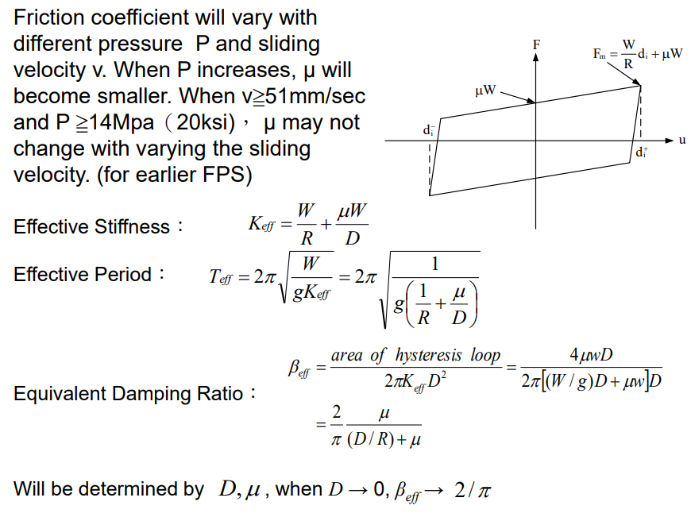

LRB

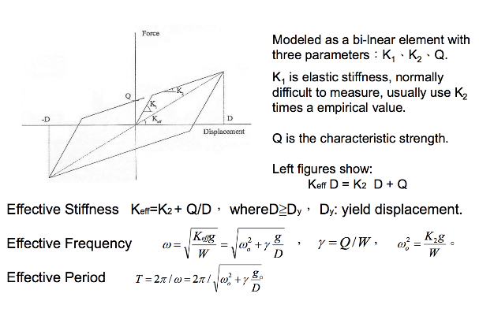

TADAS

求彈性設計反應譜

選取勁度比SR

求樓層勁度Kf

求阻尼勁度Ka

Check梁柱小於0.9Fy, 層間位移小於0.5%, 強柱弱梁

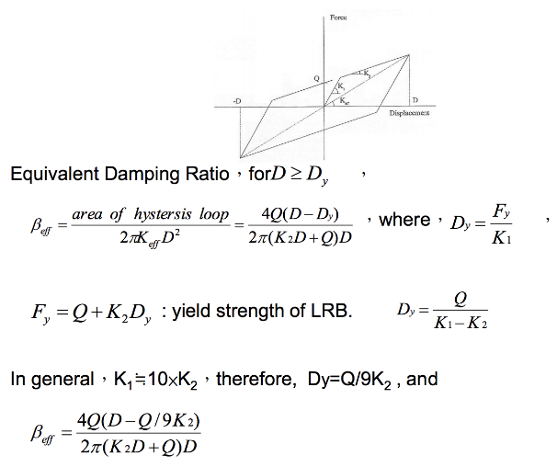

**設計流程**

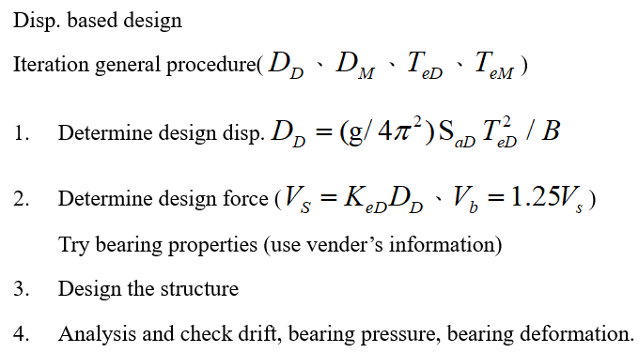

$$give T_{e}, ξ_{e}, α=>K_{e}=\frac{4π^{2}W}{T_{e}^{2}g}=>D_{D}=\frac{\frac{1}{4π^{2}}S_{aD}T_{e}^{2}}{B}=>ξ_{e}=\frac{ATD}{2πKeD^{2}}$$

$$ATD=4Q_{d}\left(D_{D}-D_{y}\right), 第一次忽略D_{y}$$

$$<=>K_{e}=K_{d}+\frac{Q_{d}}{D_{D}}<=>D_{y}=\frac{Q_{d}}{K_{u}-K_{d}}$$

**Additional Knowledge**

$$ω=2πf ω=\sqrt{\frac{k}{m}}$$

